

**The Next Generation of Digital SME Banking**

**High Level**

**Reference Documentation**

**Table of Contents**

1.1.1 Bizzy Login and Authentication 4

1.1.2 Multi-Currency Account Browser 5

1.1.3 Add a Beneficiary (Payments and Transfers) 6

1.1.4 Add a Client 7

1.1.5 Bill Payments 8

1.1.6 Invoice Generation 9

1.1.7 Payroll 10

1.1.8 Funds Transfer 12

1.1.9 Digital Onboarding 14

**Bizzy Product Roadmap** 15

1.1.10 Bizzy’s Digital Onboarding Architecture 17

1.1.11 Bizzy Onboarding Platform Services 18

1.2 Bizzy Technical Architecture 19

**What is Bizzy?**

*‘Bizzy’ : (ˈbɪzɪ) n, pl. “Biz”, “Business”, “Busy as a Bee”, “Hardworking”, “A Busy Bee”*

Bizzy is a digital solution by Thynk Digital that brings SME business banking into the digital era. We built Bizzy as a solution for small businesses, startups, limited companies, sole traders, contractors and freelancers.

We believe there is something different about people who start their own business – a unique spirit that sets them apart. A blend of entrepreneurial drive, ambition and self-belief. With that in mind we built an app that embraces that spirit – one that SME customers can rely on and makes managing finances as fast and simple as possible. Having started with a blank sheet of paper we designed an app from the ground up that takes the stress out of SME banking – something we see as a serious gap in today’s market. Our mission was to create the ultimate banking platform for entrepreneurs and small business owners, to help customers save time (and money) in the running of their businesses, so they can get back to doing what they love.

The Bizzy solution supports several business models. It is possible to launch the proposition as a fully independent business that leverages the security and regulation of an existing banking license holder. Alternatively, the Bizzy solution was developed with an API architecture at its core, which also allows it to be rolled out seamlessly as an accelerator for an existing bank’s SME proposition. Leveraging the bank’s existing features and functionality and current core systems, the Bizzy solution will reduce the time to market by a minimum of 50%. Where available and relevant, Bizzy will leverage existing core capabilities from the bank partner, including the provision of their existing API suite and delivery capability.

From a UAE perspective, we are looking to launch Bizzy as a proposition that delivers market-leading products and services and addresses the specific needs of SME’s and in particular, micro-businesses which have been under-represented in terms of access to SME banking services due to the high cost to acquire and serve relative to profitability.

As part of a phased product roadmap approach, the initial release (MVP) will incorporate the foundational level components and is targeted to be ready for launch by Q1 2020. With a primary focus on customer acquisition, the MVP will look to specifically address the needs of micro-businesses. Future phases will focus on scaling the product, both in terms of the incorporated features and customer acquisition.

**Our Objective**

Our MVP objective is to have a live, scalable and coherent solution which meets the following criteria:

* Delivers the foundational use cases required to provide customers with their basic SME banking needs
* Build, launch and operate an MVP that will seamlessly scale over time, both in terms of the incorporated features and customer acquisition volume
* Create a prioritized feature roadmap for future delivery phases

### Bizzy Login and Authentication

This module provides Bizzy with the authentication capability. We have developed the authentication module as an API-led interface to leverage a bank’s existing authentication standards and protocols. Intrinsic to the authentication is a biometric component that uses the native fingerprint authentication of the phone. This is standard with most banking fingerprint login processes and does not require bespoke enrollment just for FAB. We have also developed the transaction execution capability in such a way that it can either use fingerprint scan, a secure PIN, or OTP for validating a transaction prior to execution. In subsequent releases it will also include maker-checker roles.

### Multi-Currency Account Browser

This module is used to display and browse (through swipe or tap) multiple SME accounts which can include multi-currency, and be able to check previous monthly balances easily as well as a predefined number of ‘last’ transactions.

This view can be considered the default dashboard view after login.

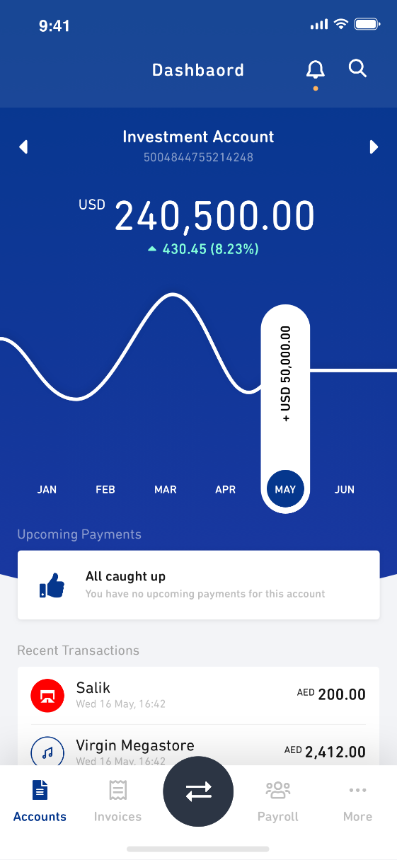 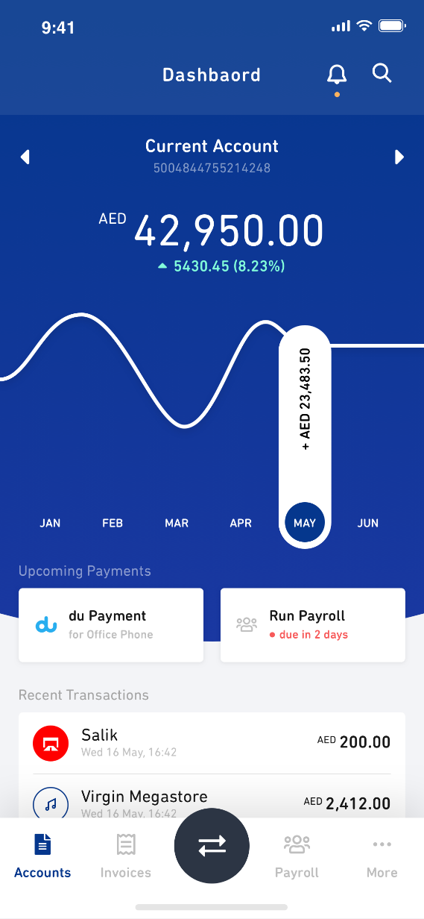

### Add a Beneficiary (Payments and Transfers)

This module allows the user to “Add a Beneficiary for fund transfer or Bill Payment.”

As part of the MVP release the beneficiary management includes the following basic features (Add, Update, Delete – multiple accounts per beneficiary, local and international)

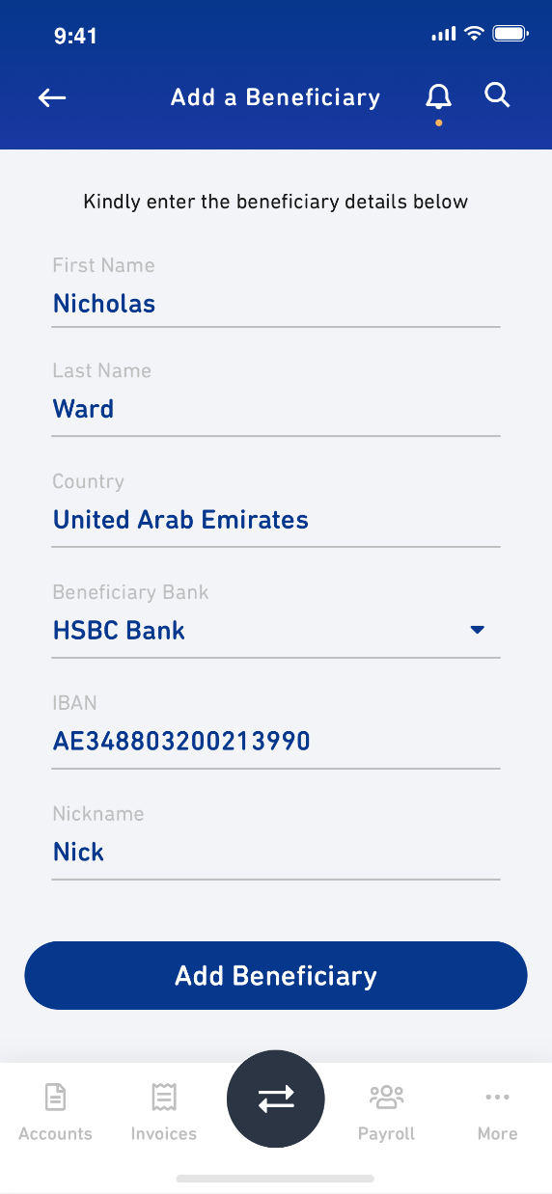

### Add a Client

This module allows the user to “Add a Client for Invoicing.”

As part of the MVP release the client management includes the following basic features (Add, Update, Delete – multiple accounts per client, local and international)

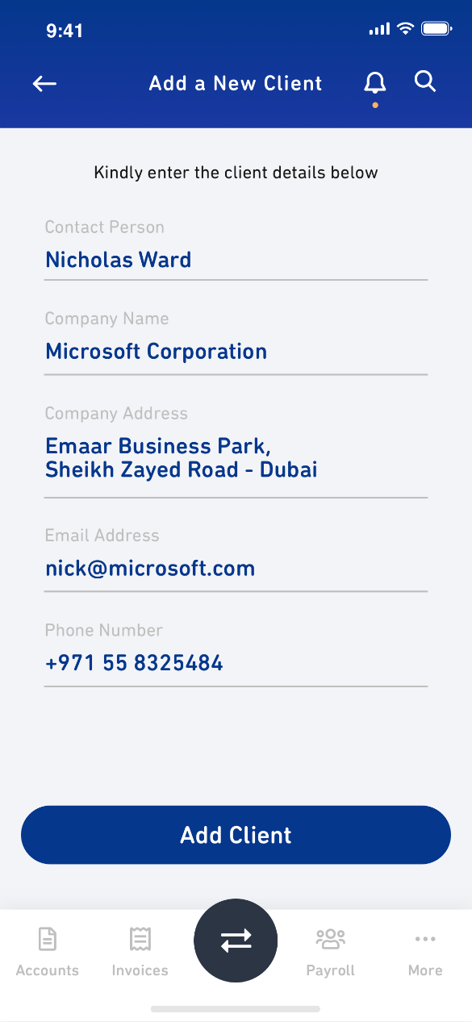

### Bill Payments

Provide basic functionality of keeping track of bills/payments to be made that can be segregated as recurring expenses or business expenses to enable better mapping for cash flow statement

* Add bills (payment to vendors, payroll, post-dated cheques etc.)
* Setup of standing instructions for recurring bills e.g. utility payments, vendor payments etc.
* Manual tagging of outward payments with bills

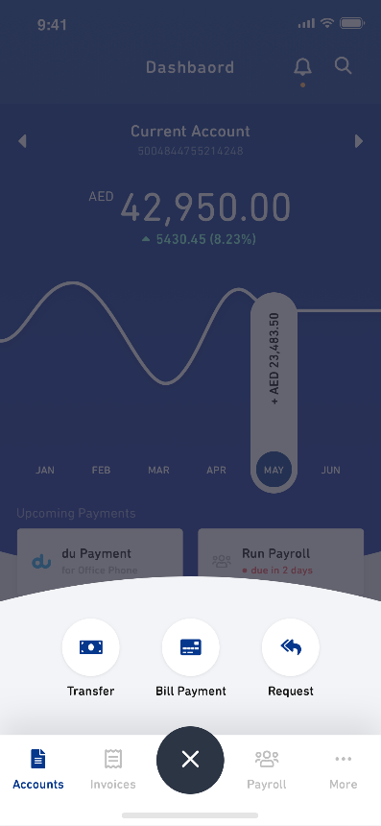 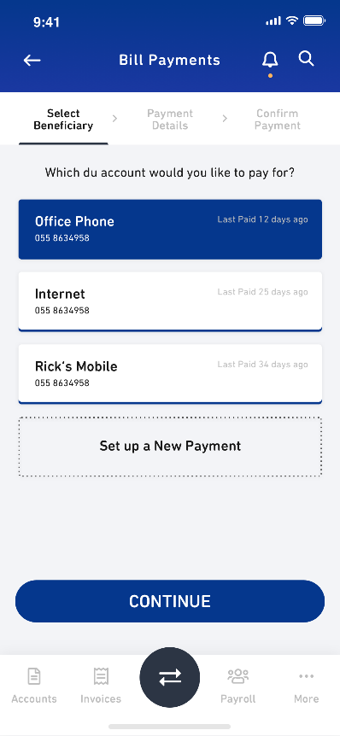 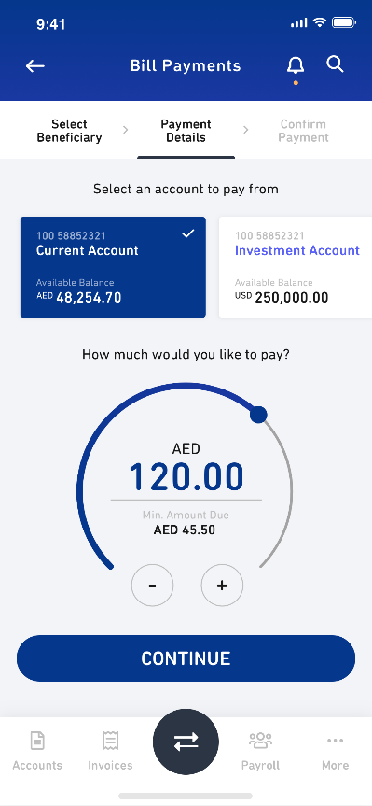

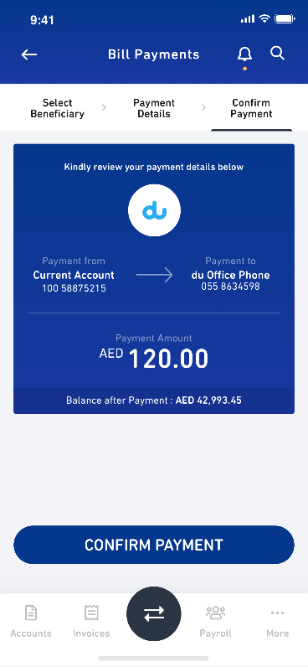 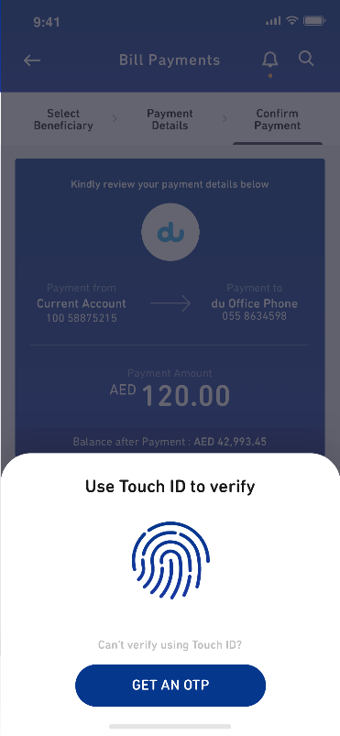 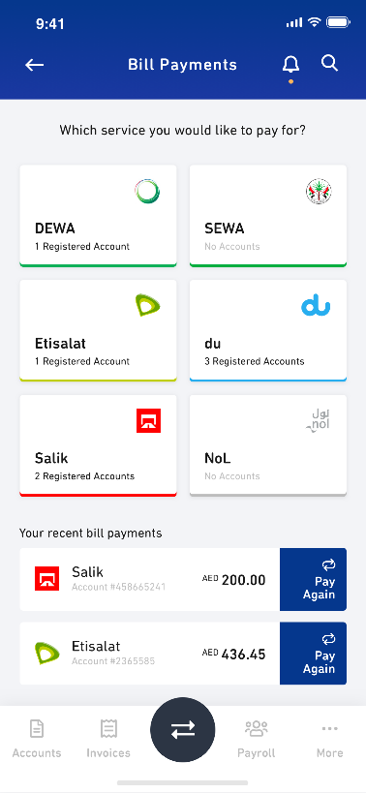

### Invoice Generation

Invoicing with tax considerations for the 5% VAT standards in the UAE

* Customer management (Add, Update, Delete – multiple companies)
* Customize standard invoice templates (goods, services, various formats)
* Generate and issue PDF invoices for customers, including a VAT calculation (quotation, invoice, receipt)
* Manual tagging of inward payments with invoices; including notifications suggesting outstanding invoices for marking and issuance of Receipts

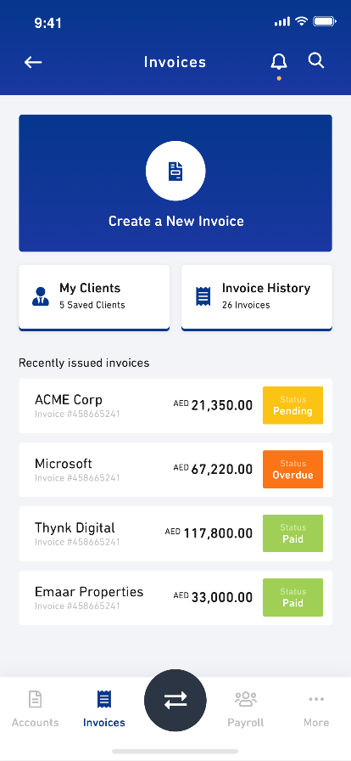 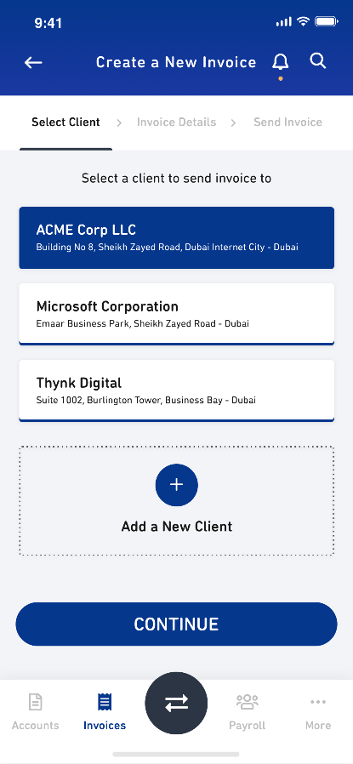 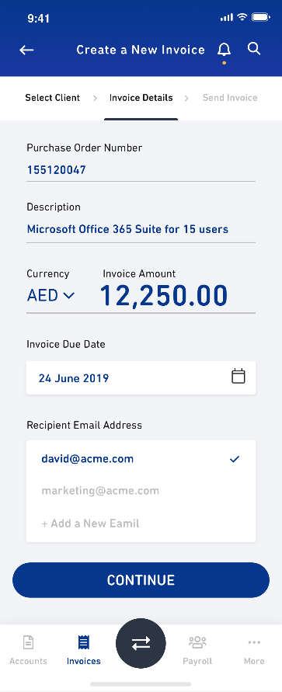

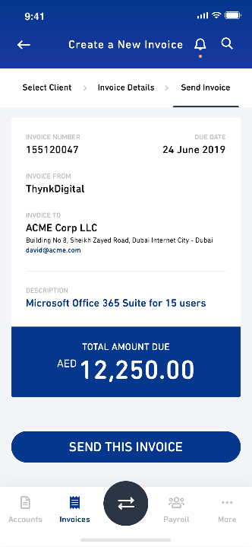

### Payroll

Payroll management (Add, Update, Delete WPS or Beneficiary employees/contractors, calculate salary, allowances, bonus etc and allow for upload of payroll team using excel or csv file, generate salary slip etc)

* Payroll Wage Protection System (WPS) processing capability

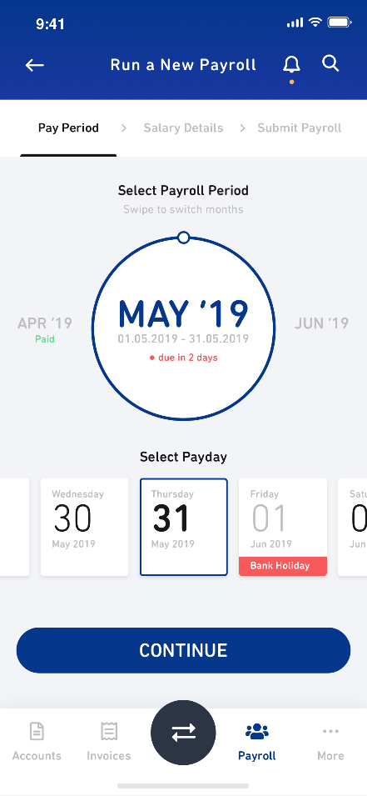 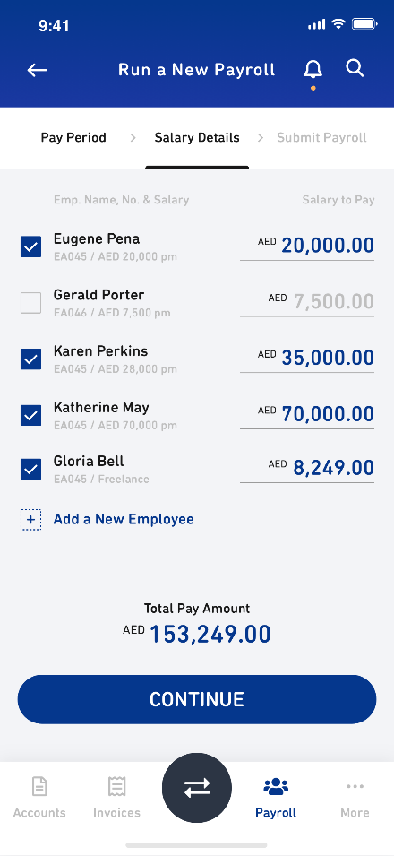 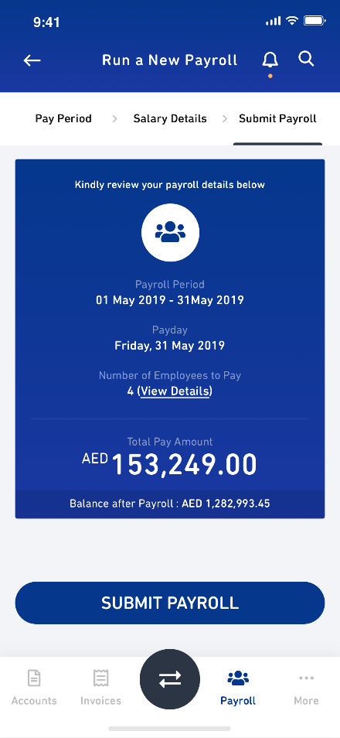

### Funds Transfer

Paying suppliers and vendors is a critical part of the Bizzy workflow. This section covers the transferring of money out of an SMEs account to a vendor, supplier or other relevant account. This process is initiated from the SMEs device and should be seamless and intuitive.

Beneficiary management (Add, Update, Delete – multiple accounts per beneficiary, local and international)

* AED domestic transfers to valid bank accounts
* Foreign currency (USD, GBP, Euro, SAR) payments to valid international bank accounts
* Utility bills and government payment (e-dirham, Noqodi)
* Instant account transfers within group accounts in UAE.
* Integration with Microsoft Supply Management Solution and Vendor Trade

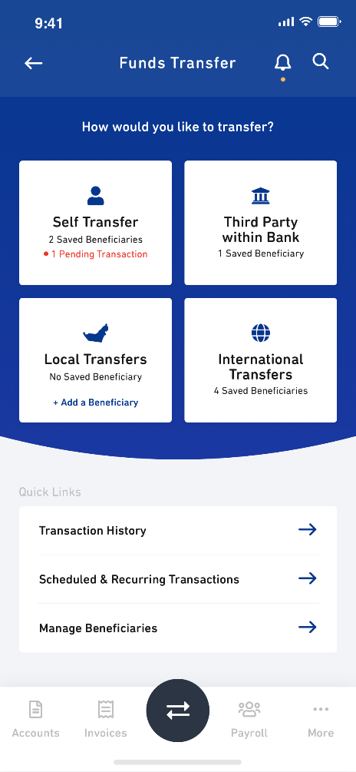 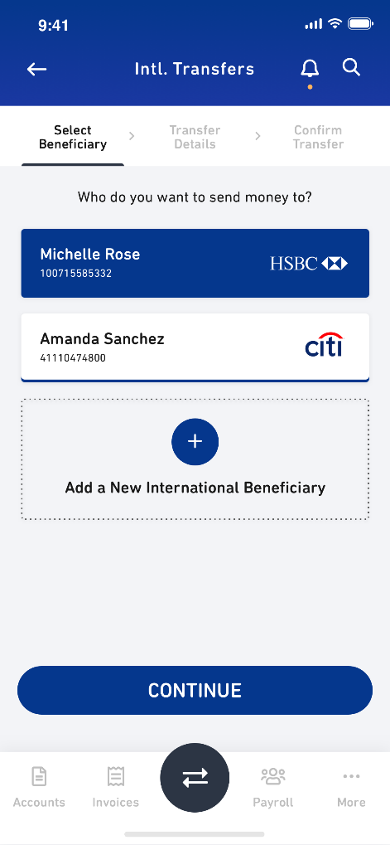 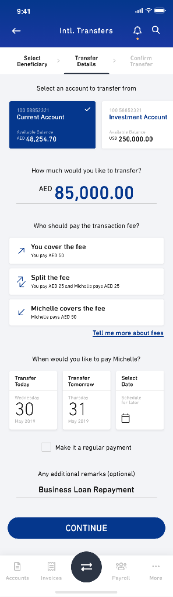

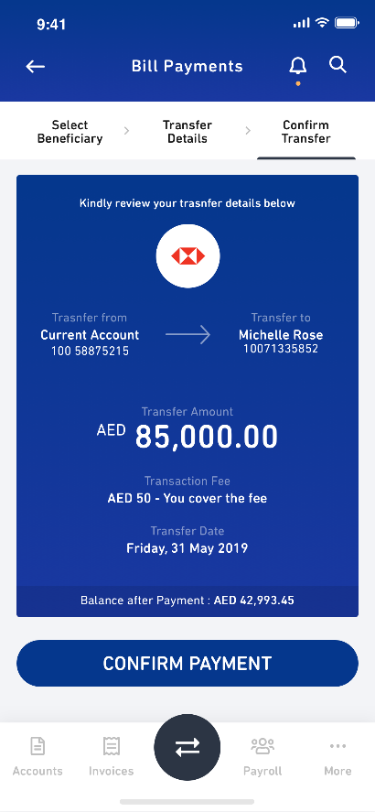 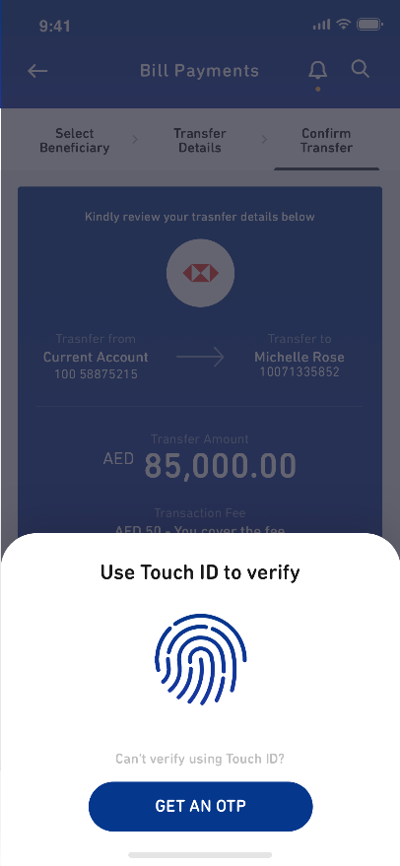

### Digital Onboarding Platform

Our digital onboarding platform provides the perfect accelerator framework for developing the user experiences SME onboarding. This typically reduces greenfield development time by 70%. The accelerator provides out-of-the-box features like the ability to scan EmiratesID, Passport, DED Trade License and UAE Utility Bills and automatically extract the customer data needed to prepopulate the application forms.

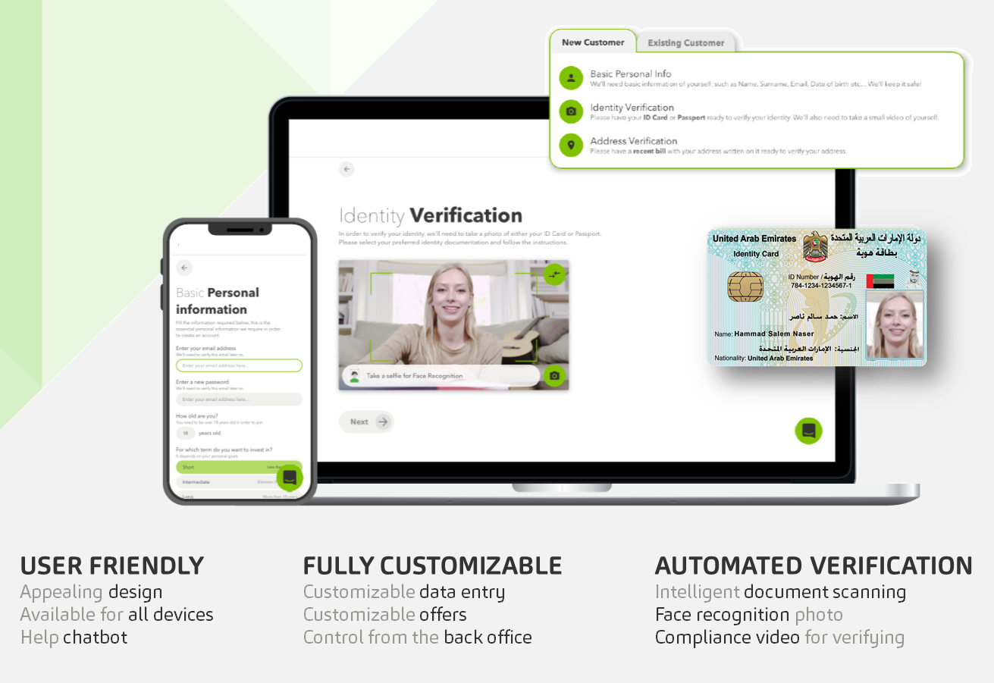

Our accelerator onboarding framework provides components like omni-channel onboarding, live-chat and chatbot functionality, a business-driven user interface and most importantly a groundwork foundation for developing additional onboarding journey’s across other SME products like credit cards, loans, and insurance policy generation.

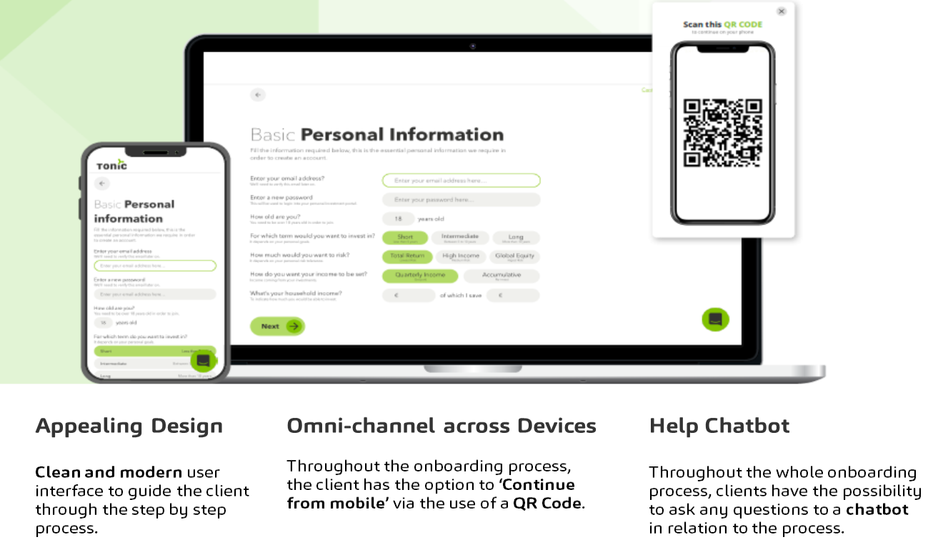

**Intelligent document scanning.**

Documents are scanned and information automatically extracted for the client to confirm, rather than clients having to manually enter details. The list of documents supported for verification purpose is configurable: DED Trade License, EmiratesID Card, Passport and/or credit check with the Etihad Credit Bureau.

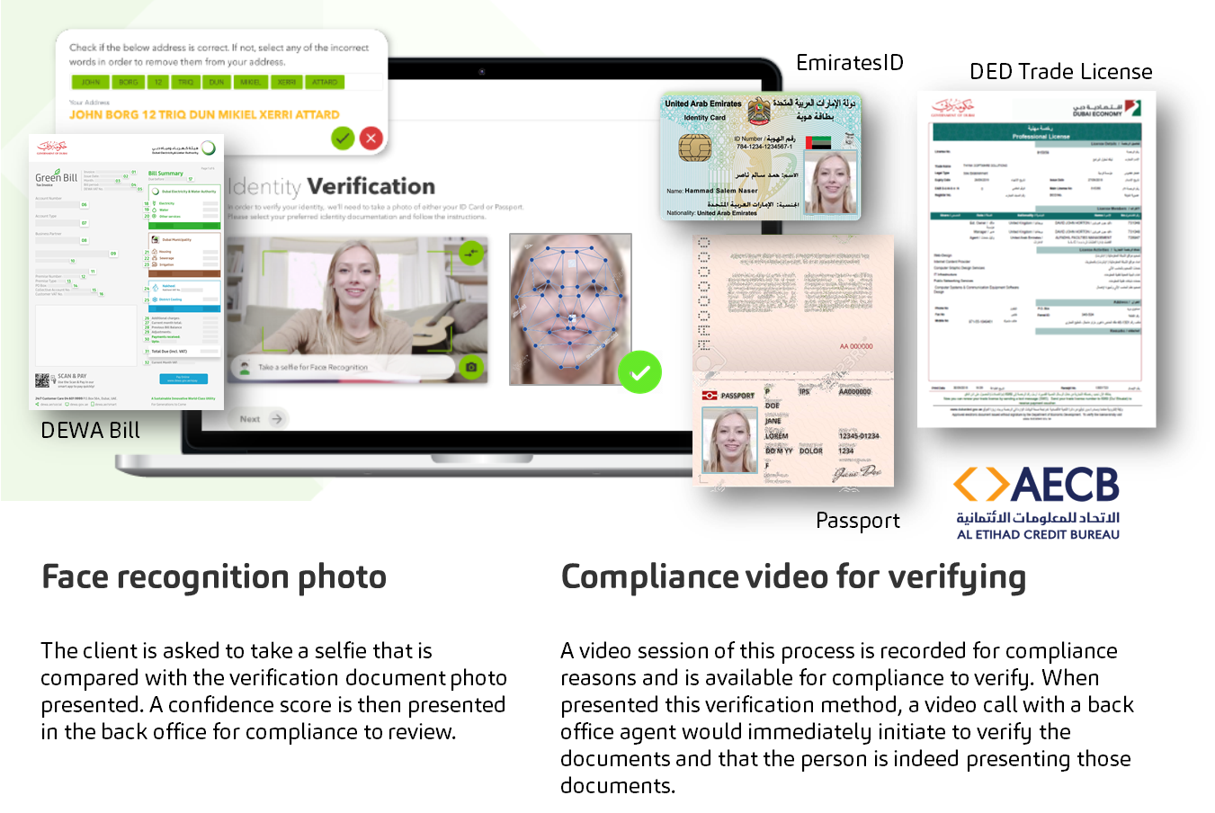

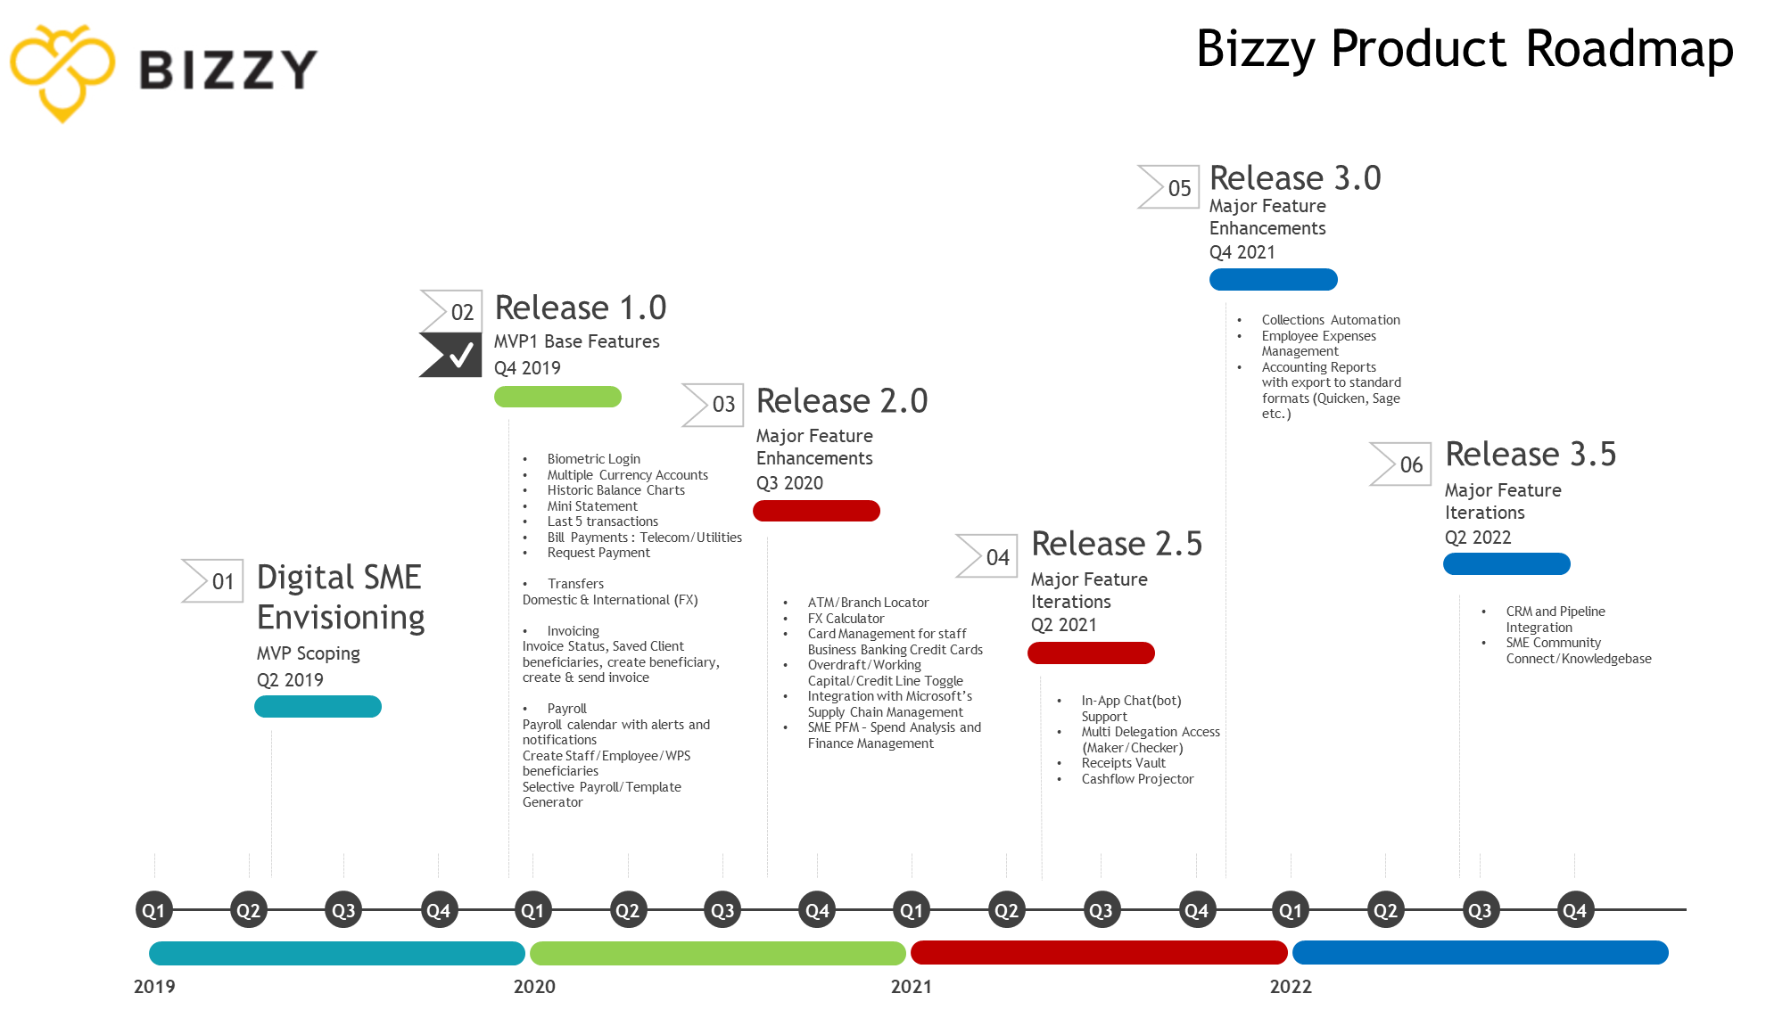

### Bizzy’s Digital Onboarding Architecture

This section pertains to the initial opening of an account by a new SME customer. Allowing them to open an account as smoothly as possible and where possible, all verification being automated using government administered IDs.

* End-to-end digital account opening for Dubai-based sole traders (single directorship company) with an Emirates ID / UAE Pass and a trade
* Instant issuance of account details and associated collateral

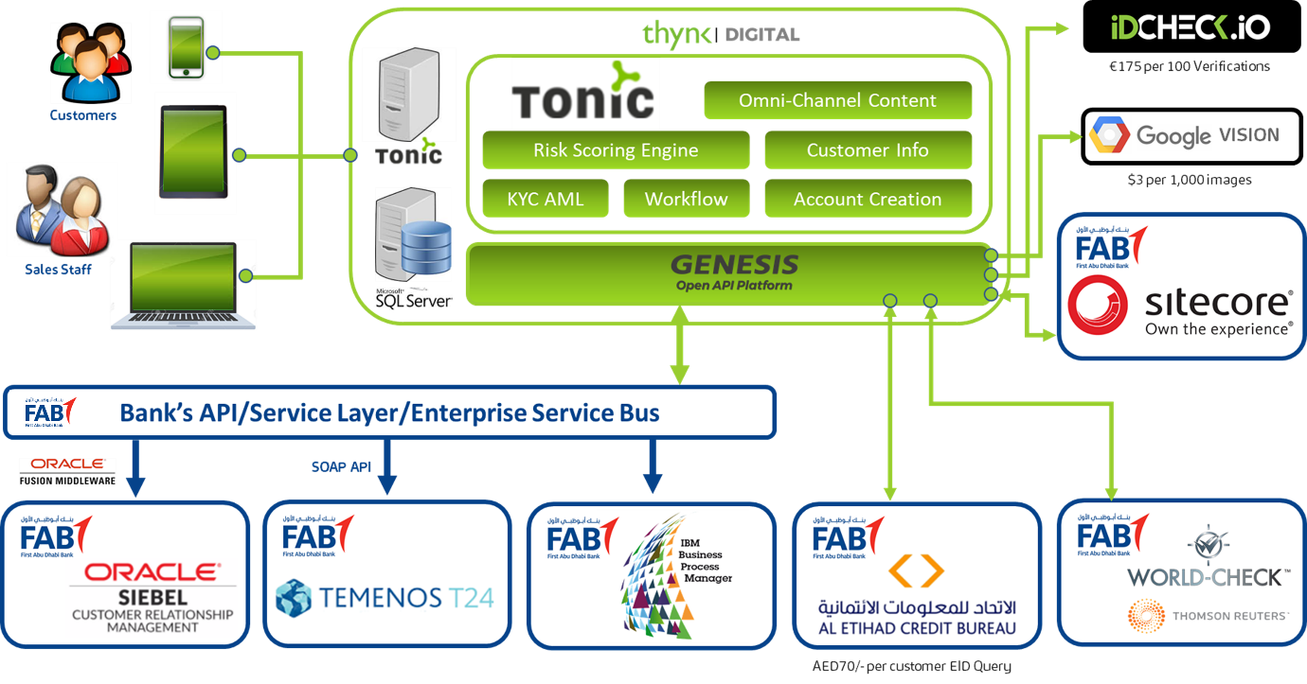

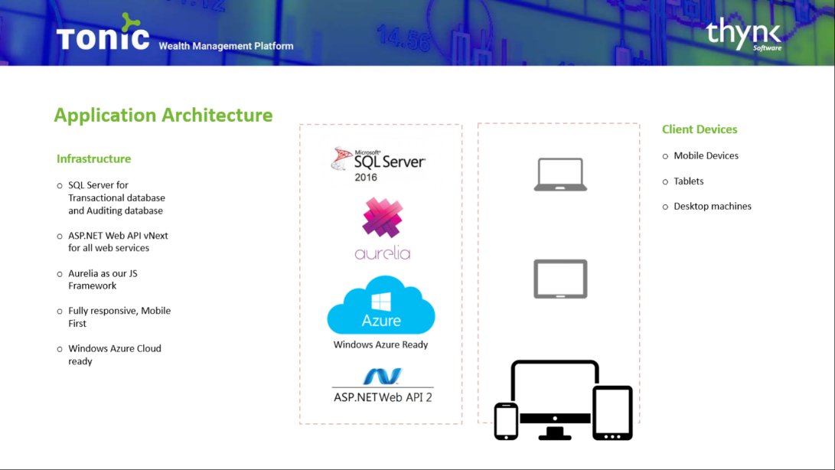

### Bizzy Onboarding Platform Services

These are the web services / web apps which are consumed directly by end users. End users being SME Customers and Internal Bank Staff consuming the back offices services / web app.

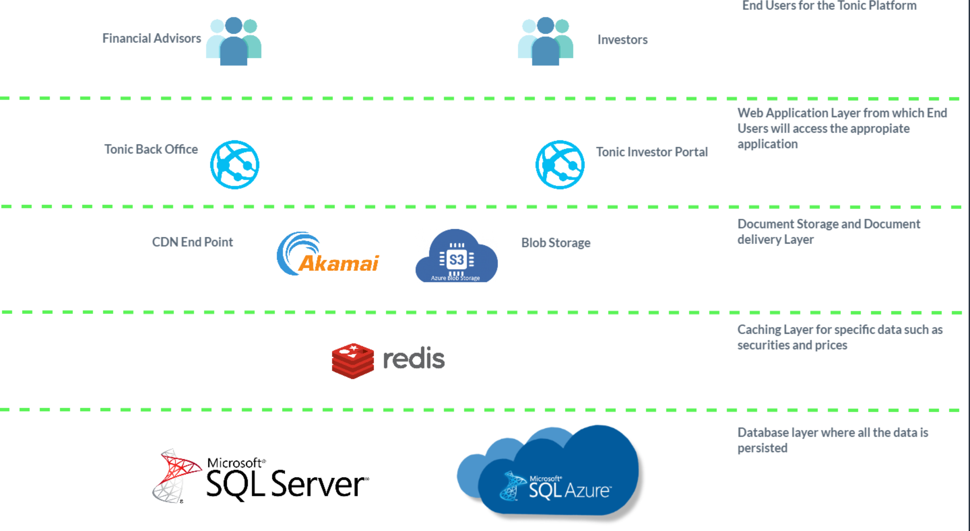

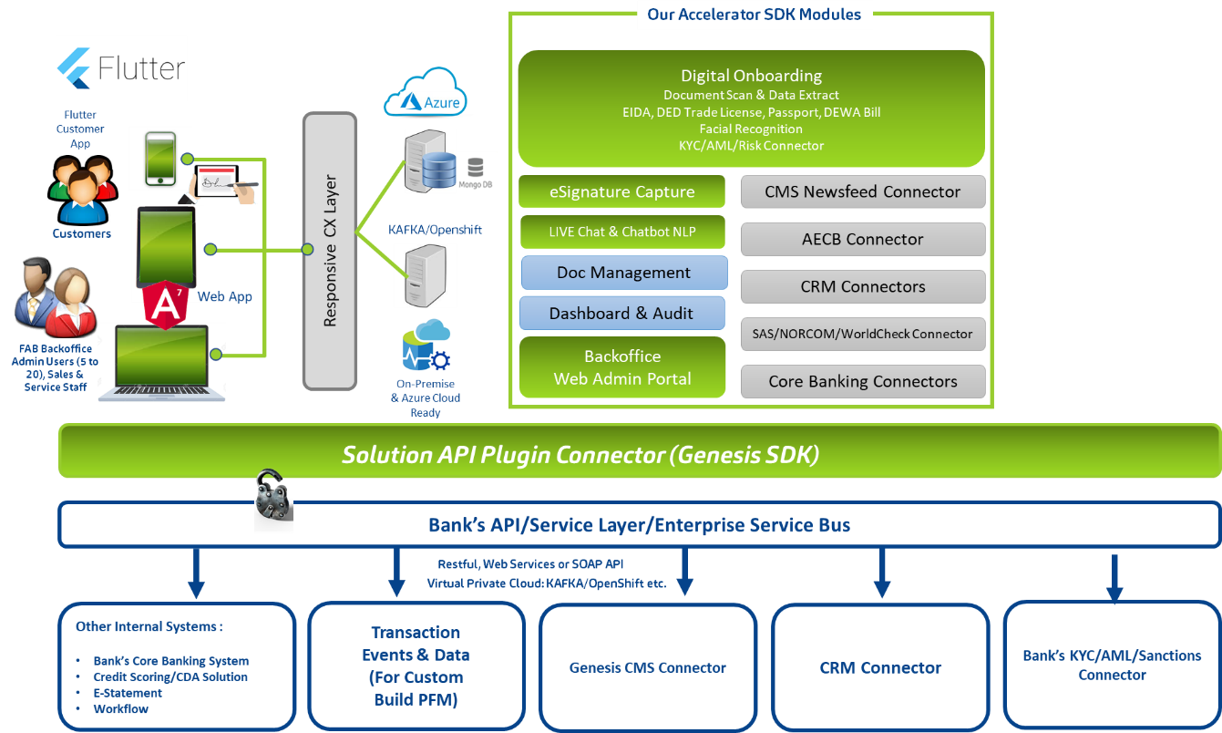

## Bizzy Technical Architecture

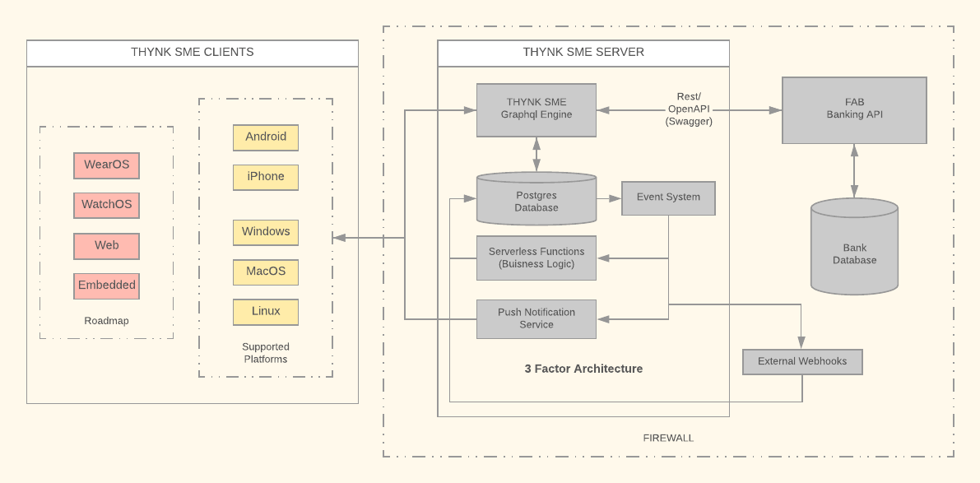

**Overview**

The Bizzy architecture is flexible and can be tailored based on the bank’s preferable technology stack, however if none exists then we have used a real time graphql database with mobile and desktop clients. We also have web, watch and embedded client support on our roadmap. Our server stack can use Facebook’s GraphQL protocol (<https://graphql.org/>); unlike REST, GraphQL allows for requesting specific data that a client needs, departing from the fixed data structure approach. Additionally, it allows advanced features like live queries, not possible with traditional REST. On client side we have chosen Google’s Flutter (<https://flutter.dev/>) as our layout engine technology. By virtue of this choice we have consolidated all our client layout logic in a single code base. There is still android or iOS specific code to interact with platform sensors etc. but 90% of the code is centralized via this approach. This results in consistent layout across all platforms for which we can write tests in a single application foundation. Flutter seamlessly runs on android, iOS and across desktops alike since it contains its own native rendering engine called Skia (<https://skia.org/>). It’s designed have a high-performance 120 frames/sec experience. Prior to the MVP release it is anticipated that it will also support web and embedded systems.

**All the software libraries in our technology stack are open source.** Below is the list of libraries currently being used, however we are able to customize the solution if alternative libraries are preferred by the bank.

Libraries

**Server**

* Graphql Engine - https://github.com/hasura/graphql-engine
* Database - https://github.com/postgres/postgres
* Business Logic - https://github.com/serverless/serverless
* Serverless Functions - https://github.com/serverless/serverless
* Devops - https://github.com/kubernetes/kubernetes

Our devops is deployed on Microsoft's Azure services.

**Client**

* Layout engine - Flutter (https://github.com/flutter/flutter)
* Android – Kotlin
* iOS - Swift
* Desktop app - Golang using GLFW (https://github.com/golang/go)

**Server Architecture**

Tri-factor app is an architecture pattern for modern full-stack apps. Today, it is possible to build apps that have high feature velocity and scalability from inception.

We propose or recommend an architecture pattern which is composed of 3 factors:

1. Realtime GraphQL
2. Reliable eventing
3. Async serverless

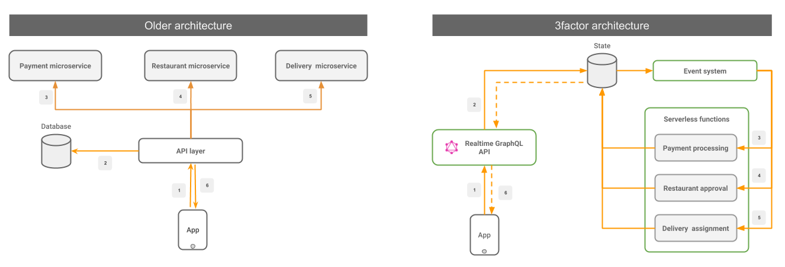

## 

## **Factor #1: Realtime GraphQL**

Use GraphQL for a very simple and flexible frontend developer workflow. GraphQL is a crucial component for delivering high feature velocity. Your GraphQL layer should also support the following 2 properties:

* **Low latency**: An end-user should see instant feedback of an action and not have to wait long on an API (<100ms ideal, up to 1 second at worst).
* **Support subscriptions**: Consume information “Realtime” from the backend via GraphQL Subscriptions. Avoid the use of continuous polling (thereby reducing resource consumption).

## 

## **Factor #2: Reliable eventing**

Remove in-memory state manipulation in your backend APIs and persist them as atomic events instead. Having an immutable event log helps in crash recovery, replicability and observability among others. Your event system should have the following 2 properties:

* **Atomic**: Mutations to the application state should atomically create event(s).
* **Reliable**: Events once emitted should be delivered (to any consumer) at least once.

## **Factor #3: Async serverless**

Write business logic as event handlers. Deploy these event handlers on serverless compute. Serverless minimizes backend ops and gives free scalability while being cost-efficient. The serverless backends should follow these best practices:

* **Idempotent**: The code should be prepared for at least once (for same event) delivery of events.
* **Out-of-order**: Events may not be guaranteed to be received in the order of creation. The code should not depend on any expected sequence of events.

In short, a tri-factor app requires you to remove state from your code and put it in your datastore and/or event queues as much as possible. Cloud vendors make it easy to scale and replicate your datastore, event-queues and compute backend. Consuming asynchronous information and performing sync actions in the frontend requires a high-performant Realtime GraphQL API.

An interesting side note: A 3factor app’s architecture is analogous to the redux dataflow model on a react app, but applied to the full stack.

**Client Architecture**

Flutter is Google’s UI toolkit for building beautiful, natively compiled applications for mobile, web, and desktop from a single codebase.

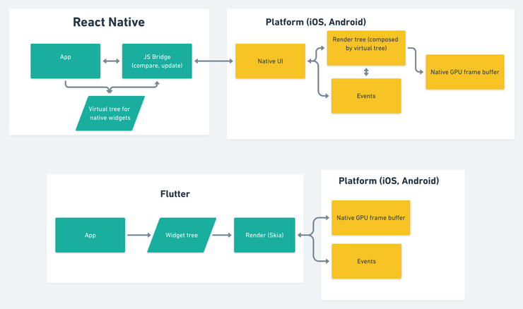

It uses Skia in backend as rendering engine. Skia is an open source 2D graphics library which provides common APIs that work across a variety of hardware and software platforms. It serves as the graphics engine for Google Chrome and Chrome OS, Android, Mozilla Firefox and Firefox OS, and many other products.

Skia is sponsored and managed by Google but is available for use by anyone under the BSD Free Software License. While engineering of the core components is done by the Skia development team, they consider contributions from any source.

**Advantages of adopting Flutter**

* Supports Android, iOS
* Works with desktop windows, mac, Linux, embedded device (like kiosks, touch screen) (Soon official support)
* Web (under development)
* Delivers a superior Customer Experience with fast performance allowing flawless rendering on upcoming 120/90hz (i.e 120 or 90 frames per second) devices.
* Opensource – Just like our whole stack, this provides free and opensource license with backing of Google.
* Consistent - With Centralized Layout engine comes benefits like Open - source skia engine - less testing required
* Precise (Control over pixel)
* Significantly faster Development cycle
* Opensource; security auditable
* Flutter developers is the fastest growing job skill on LinkedIn (recruitment)